**Instrumentation Manual**

**Lab 1**

**Patrick Devaney**

**G00398151**

**06/11/2020**

# Table of Contents:

1 Table of Contents: 2

2 Table of Figures: 3

3 Task 4 Build your first program 4

4 Task 5 Blinking LED on Breadboard 5

5 Task 6 Fading LED 6

6 Task 7 adding more LEDs 7

7 Task 8 Add a pot to the board 8

# Table of Figures:

Figure 1 Code for blinking internal light 4

Figure 2 Code for blinking light on Breadboard 5

Figure 3 Blinking Led connected to Breadboard 5

Figure 4 Code for fading LED 6

Figure 5 Fading LED connected to Breadboard 6

Figure 6 Task 6 Adding two extra LEDs 7

Figure 7 Two Leds added to LED from task 6 7

Figure 8 Task 8 Adding a pot 8

Figure 9 Variable resistor connected to Breadboard 8

# Task 4 Build your first program

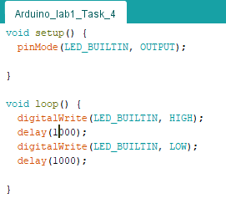

Figure 1 Code for blinking internal light

This program blinks the internal led of the Arduino board, on for 1 second and off for 1 second

# Task 5 Blinking LED on Breadboard

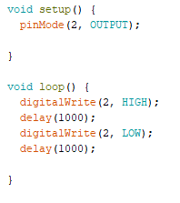

Figure 2 Code for blinking light on Breadboard

This program blinks an External LED connected to a breadboard and controlled by the Arduino controller, on for 1 second and off for 1 second.

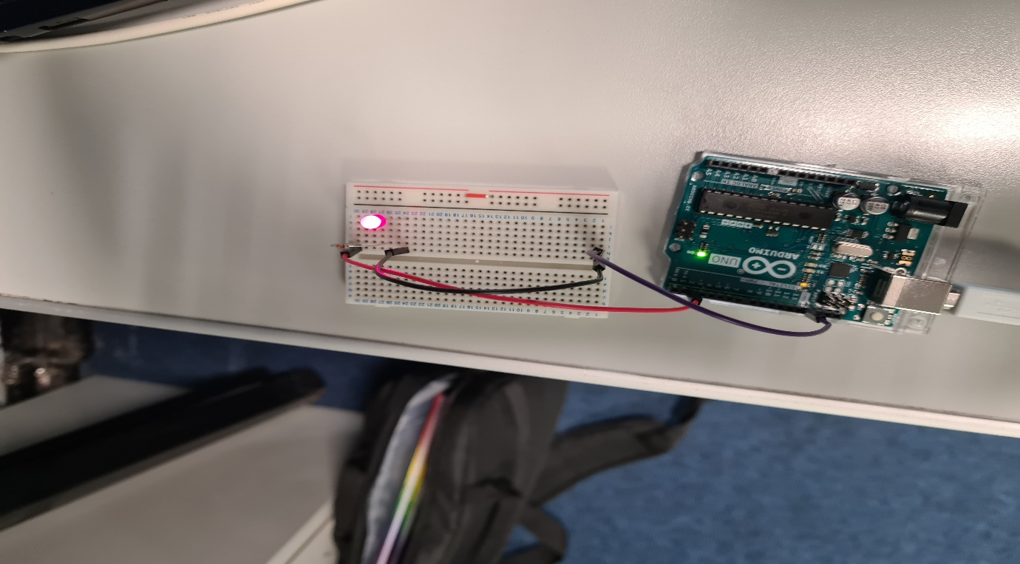

Figure Blinking Led connected to Breadboard

# Task 6 Fading LED

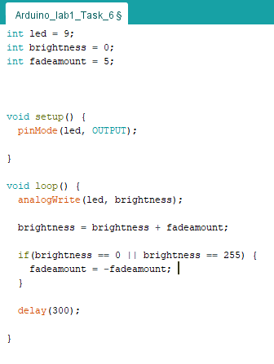

Figure 4 Code for fading LED

This uses the LED connected in task 5 and dims and brightens the LED controlled by the Arduino controller.

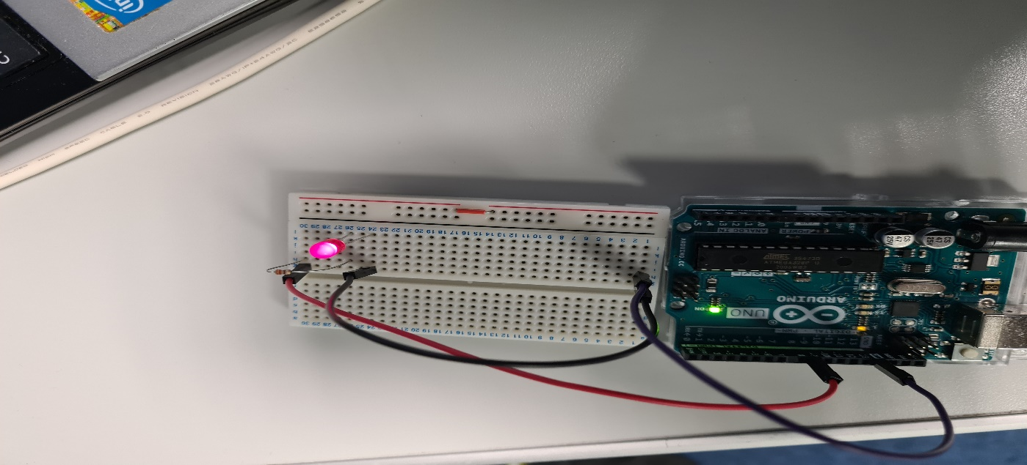

Figure Fading LED connected to Breadboard

# Task 7 adding more LEDs

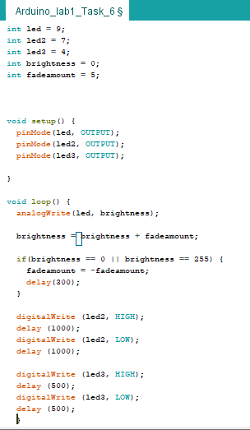

Figure 6 Task 6 Adding two extra LEDs

We have added two more LEDs to the LED used above one of the extra LEDs blinks every second the other blinks every half second and the third dims and brightens, all controlled by the Arduino controller

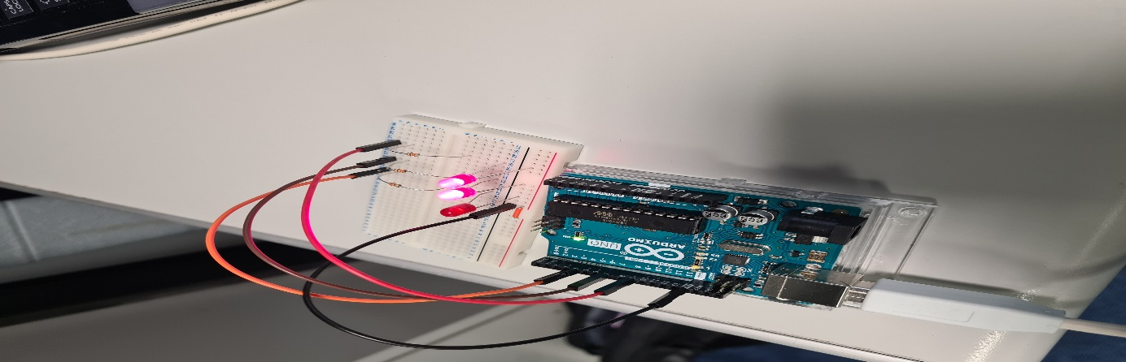

Figure Two Leds added to LED from task 6

# Task 8 Add a pot to the board

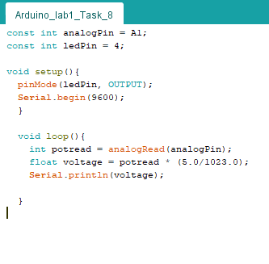

Figure 8 Task 8 Adding a pot

In this task we have connected a variable resistor to the breadboard and are converting the signal into volts and prints this to the serial register.

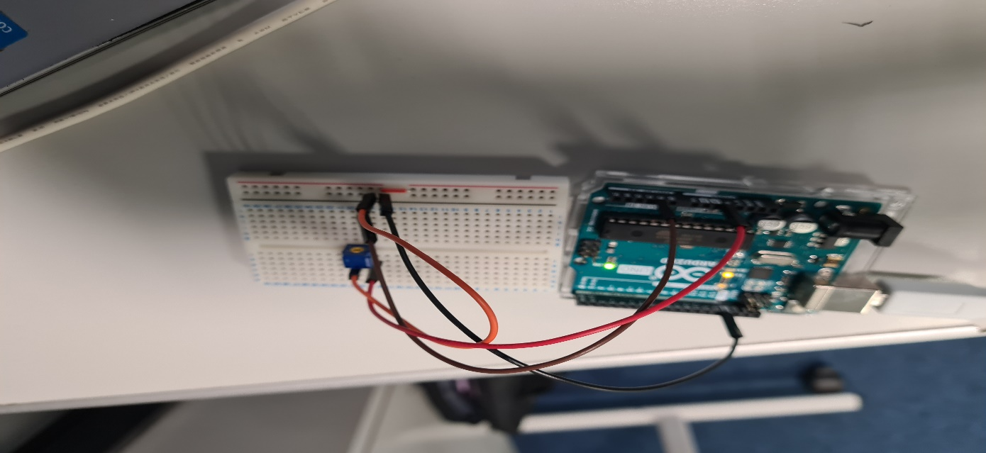

Figure Variable resistor connected to Breadboard